AGENDA

* 10 NOVEMBER (5u)
* 5 DECEMBER (3u)

<https://www.eventbrite.nl/e/tickets-pitchpizza-27727366299?utm_source=eb_email&utm_medium=email&utm_campaign=order_confirmation_email&utm_term=eventname&ref=eemailordconf>   
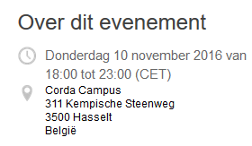

<http://www.unizo.be/activiteiten/starten-als-zelfstandig-ondernemer_05-12-2016-0>

